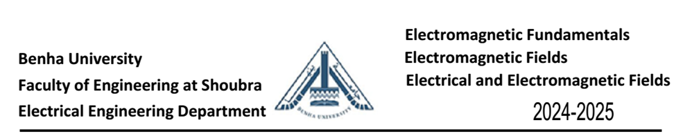
Part 2 - Sheet 3
$\boxed{1}$ The magnetic field intensity is given in the square region x=0, 0.5 < 𝑦 < 1 , 1 < 𝑧 <1.5 by 𝐻 = 𝑧²𝑎_{𝑥}+ 𝑥³𝑎_{𝑦}+ 𝑦⁴𝑎_{𝑧} A/m.
a) Evaluate ∮ 𝐻. 𝑑𝐿, about the perimeter of the square region.
b) Find ∇ × 𝐻
c) Calculate (∇ × 𝐻)_{𝑥} at the center of the region.
$\boxed{2}$ A wooden rail Toroid with internal radius, a = 25 cm, external radius, b = 45 cm number of turns, N =500 and carries current, I = 1 mA. Find the magnetic field intensity and the magnetic flux density at the center of this Toroid if µ_{r} = 1 for wood.
$\boxed{3}$ A Toroid of a ring-shaped coil, shown in Fig. 3.18, whose parameters are: the mean radius r_{av} = 10 cm, winding is uniformly distributed and contains number of turns, N =200 turns and wound on a wooden core with diameter, d = 2 cm. If it carries current, I = 1 mA do the following:
(a) Derive an expression for the self-inductance L.
(b) Calculate L for the given parameters if µ_{r} = 1 for wood.
$\boxed{4}$ A circular cross-section conductor of radius, r = 2 mm carries an ac current, i_{c} of i_{c} = 2.5 sin (5 x 10⁸ t) µA. What is the amplitude of the displacement current density if the conductivity of the materials, σ= 35 MS/m and the relative permittivity, ε_{r}= 1?
$\boxed{5}$ In a material for which the conductivity of the materials, σ= 5 S/m and the relative permittivity, ε_{r}= 1, the electric field intensity, E = = 250 sin (10¹⁰ t) V/m. Find the conduction and displacement current densities and the frequency at which they have equal magnitudes.
$\boxed{6}$ Let µ = 3 x 10⁻⁵ H/m, є = 1.2x 10⁻¹⁰ F/m, and σ = 0 every where. If H =2 cos(10¹⁰t -βx) â_{z} A/m, use Maxwell's equations to obtain expressions for B, D, E, and β.
$\boxed{7}$ A certain material has σ = 0 and є_{R} =1. if H = 4sin(10⁶t – 0.01z)ay A/m, make use of Maxwell's equations to find µ_{R} and E(z, t).

